PIZZA SALES SQL QUERIES

- KPI’S:

- Total Revenue:
SELECT SUM(total_price) AS Total_Revenue from pizza_sales;
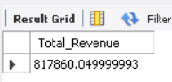

- Average Order Value:
SELECT SUM(total_price) / COUNT(DISTINCT order_id) AS Average_Order_Value from pizza_sales;
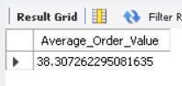

- Total Pizzas Sold:
SELECT SUM(quantity) AS Total_Pizza_Sold from pizza_sales;
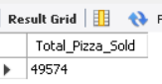

- Total Orders:
SELECT COUNT(DISTINCT order_id) AS Total_Orders from pizza_sales;

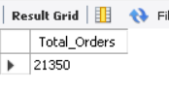

- Average Pizzas Per Order:
SELECT CAST(SUM(quantity) / COUNT(DISTINCT order_id) AS DECIMAL(10,2)) AS Avg_Pizzas_Per_Order from pizza_sales;

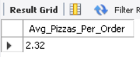

- CHARTS:

- Daily Trends for Total Orders:
SELECT
DAYNAME(order_date) as Order_Day,
COUNT(DISTINCT order_id) AS Total_Orders
FROM pizza_sales
GROUP BY DAYNAME(order_date);

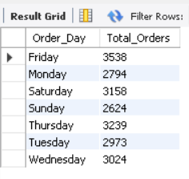

- Hourly Trends for Total Orders;
SELECT
HOUR(order_time) AS order_hour,
COUNT(DISTINCT order_id) AS Total_Orders
FROM pizza_sales
GROUP BY HOUR(order_time)
ORDER BY order_hour;

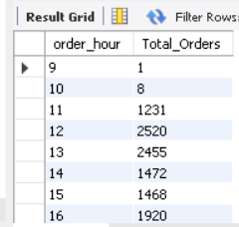

- Percentage of Sales By Pizza Category:
SELECT pizza_category, SUM(total_price)*100 / (SELECT SUM(total_price) FROM pizza_sales) AS Percentage_of_TS
FROM pizza_sales
GROUP BY pizza_category;

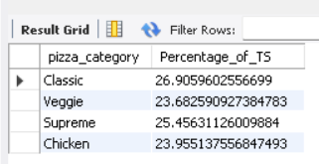
- Percentage of Sales by Pizza Size:
SELECT pizza_size, SUM(total_price)*100 / (SELECT SUM(total_price) FROM pizza_sales) AS Percentage_of_TS
FROM pizza_sales
GROUP BY pizza_size;

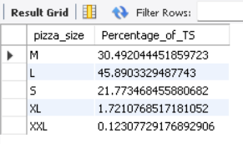

- Total Pizzas Sold by Pizza Category:
SELECT pizza_category, SUM(quantity) AS Total_Pizzas_Sold
FROM pizza_sales
GROUP BY pizza_category;

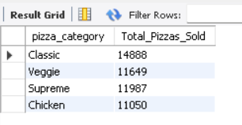

- Top 5 Best Sellers by Total Pizzas Sold:
SELECT pizza_name , SUM(quantity) AS Total_Pizzas_Sold
FROM pizza_sales
GROUP BY pizza_name
ORDER BY SUM(quantity) DESC
LIMIT 5;

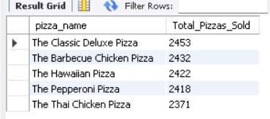

- Bottom 5 Worst Sellers By Total Pizzas Sold:
SELECT pizza_name , SUM(quantity) AS Total_Pizzas_Sold
FROM pizza_sales
GROUP BY pizza_name
ORDER BY SUM(quantity) ASC
LIMIT 5;

